**AMAZON WEB SERVICES**

Cloud Computing is delivery of services like Compute Power, Database Storage, Application and many more IT resources. It is a platform where you pay as you go. It means you don’t have to pay for whole system to use it for minimum time. You can buy only those services you want and for time you want. You can access right type and size of resources you need and time.

There are many cloud providers in the market developed by different companies- AWS, Microsoft Azure, Google Cloud Platform, IBM cloud, Digital Ocean.

AWS is a cloud based distributed IT Infrastructure to provide various services on demand by Amazon. On Demand means use what you need. You don’t have to buy whole resources if you want it for some time. AWS maintains the network connected hardware required for these application services, while you can use just via a web application. You don’t have to buy hardware.



**PURPOSE OF AWS**

1. **Flexible:** - The flexibility of AWS allows us to choose which Operating System, languages and programming models to choose for the project. Migration is easy to cloud. Building application in AWS is like building application using existing hardware resources. Flexibility is great advantages for the organization to deliver the product on time with updated technologies.
2. **Cost Effective:** - This on-demand infrastructure lets the use only required resources. After successful development, it needs Hardware and bandwidth to keep running. Owning your own infrastructure can be costly. So buying just what you require and pay only when you use is one of the main feature of AWS.
3. **Scalable:** - It is a feature that allows using the resources according to requirements. It increases and decreases by computing resources up and down accordingly. Elasticity Load Balancing and Scalable automatically scale your resources to meet the requirements. When requirements increases it automatically up the computing resources and when decreases it down the computing resources. This is very useful for shopping websites like on weekend more people do shopping but on weekday costumers decreases. So resources also adjust accordingly.
4. **Secure:** - AWS provides end-to-end security and privacy. AWS maintains CIA i.e. Confidentiality, Integrity and Availability to the data. This is an important factor of Security. Services provided by AWS are secure.

**When AWS started and from where**

AWS first launched in 2002 internally then launched publically with SQS in 2004.Then relaunched in 2006 with S3, SQS and EC2.

**Regions and Availability Zones**

Amazon cloud services are hosted in different geographical location in the world. These locations are called AWS Regions. Each AWS region is a separate geographical zone (Area). Each AWS Region has 2 or more “Availability Zones”. Each AWS Regions are independent from each other. If you create an Instance in one AWS Region, it won’t be available in another AWS Region.

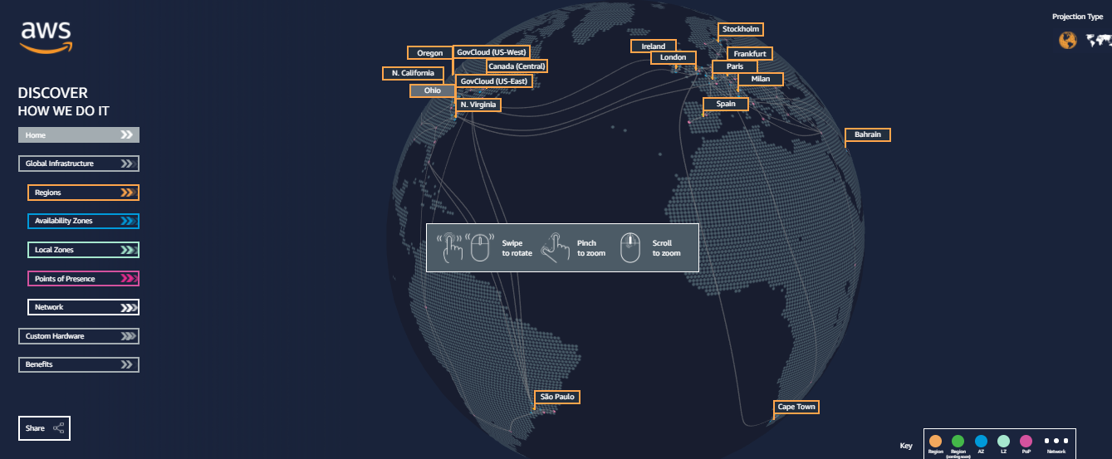

Take a look to the AWS Zones and Availability Zones of Amazon Cloud Services

<https://infrastructure.aws/>

To start with AWS, You need to create an AWS account on AWS. When you enter AWS, you are in your root account where you choose the region on right upper. There is list of regions in which services are available.You can check for services available from dropdown on upper left.

**AWS IAM – Identity Access Management**

IAM is a policy and technology for ensuring people have limited and required permissions to aws Console. It allows managing users and their level of access to aws. It is used to set permissions among the users, and groups created. Using IAM root user can control how people are allowed to use that AWS Infrastructure. IAM users such as users, groups are given services, resources and permissions by root to use according to requirements.

To Create IAM:-

1. Go to services dropdown and write IAM and click. There you will find users, groups, roles and Security Status.
2. Go to user and create user then assign a group and policy and create user.
3. A csv file will appear which you need to download as it has detail of the user created.
4. Give the User Account ID, username and password.

It is suggested that never use your root account. Create one user and use that. Keep the root details safe.

Budget Setup

Second most important to know to Budget Setup. So that you should be aware of charges. Budget setup is set up so that if you exceed the amount you are ready to spend, you get notification about your billing details. You can do this by following steps:-

1. Go to service and type Budget setup and click. Budget setup page will appear.
2. Click on “create budget” on upper right and set your budget accordingly.
3. Provide name with month etc.
4. Provide email where you want notification to appear on Configuration alert page
5. Confirm budget and create and download csv file.

**AWS Instances**

Instances are any tiny part of large computer. A tiny part has its own Hard Drive, Network Connection, Operating System etc. Everything is virtual. You can use that just on your web.

**EC2 INSTANCES:-**

EC2 means Elastic Cloud Compute provides a wide selection of types of instances for different cases. Types of Instances comprise varying combination of CPU, memory, storage, networking and flexible sizes.

**CATAGORIES OF EC2 Instances**

1. General Purpose: Most popular used for web servers and ideal for applications that uses equal resources such as web servers and code repositories.
2. Compute Optimized: These used where streaming data requires lots of processors and system.
3. Memory Optimized: used where more and more memory required.
4. Accelerated Computing: used for tasks like graphic rendering where additional hardware like GPU and FPGA to provide parallel processing.
5. Storage Optimized: Best for the tasks where huge amount of space is required.

**How to start with EC2 Instances**

1. Logout from Root and login to user account.
2. Create a free tier Instance from “Launch Instance”.
3. Choose “Instance Type”, “configuration detail’, ”add storage” , “add tags” , “configure security group” and then “LAUNCH”
4. Create a key pair and download the pem file
5. “LAUNCH INSTANCES”

Security Group: - Security Group is a virtual firewall which controls the traffic to the Instance. You can add and remove the ports allowed to inbound or outbound. You can change the ports of the security group to allow or to stop.

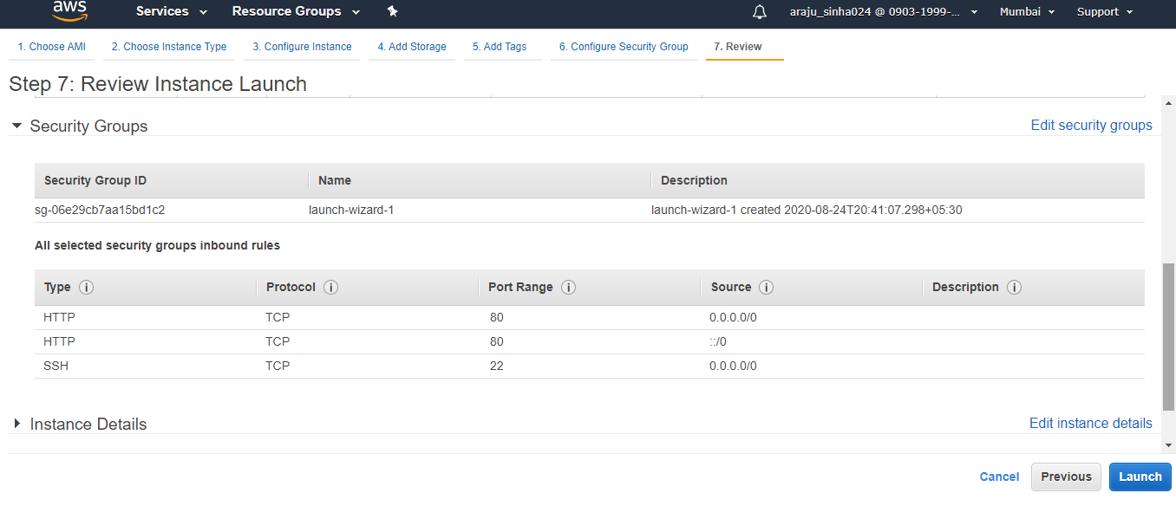

Key Pair : It allows to connect to the instances securely.

**HOW TO CONNECT TO INSTANCES AND USE**

There are 3 ways to connect

1. Using putty: A pem file is downloaded when instance was launched. Convert the pem file into ppk file using puttygen. Open putty and Enter IP of instance in host name. Then extend “ssh” under “connection” and go to “Auth” and attach the ppk file. Click Open. A terminal will open which is the instance terminal. Enter by user “Ubuntu” or “ec2-user” and start working.

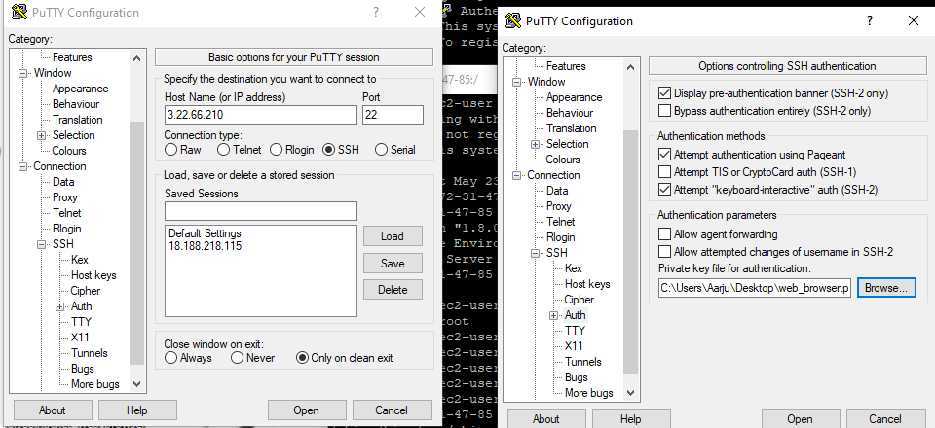

1. ssh : Open powershell on windows. Type ssh to check if ssh is available. Then run a command

> ssh -i c:\users\username\Downloads\pemfilename.pem [ec2-user@3.22.66.210](mailto:ec2-user@3.22.66.210)

i.e. ssh –i pemfile path user@Ip of Instance

1. On web: Most easy way to connect when neither of them worked. Click on “connect” and select “EC2 Instance Connect (browser-based SSH connection)” and give username. Click on connect. Your terminal will open on a web browser.

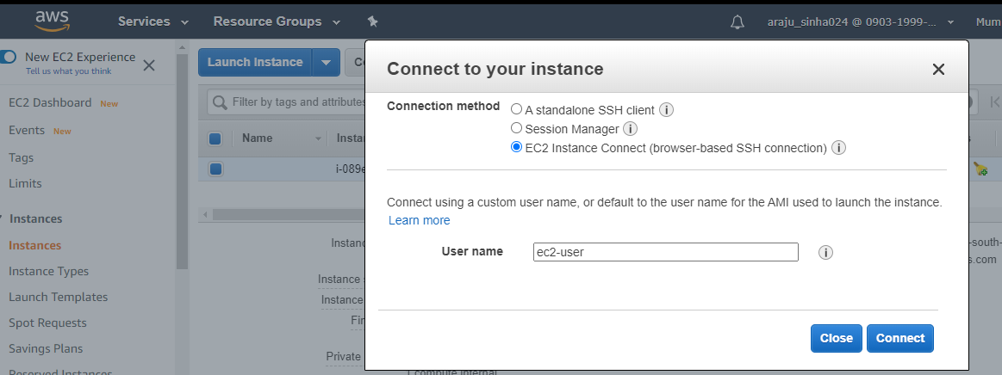

Amazon web Services offers large set of cloud based products like Storage, Database, Compute, Analytics, Mobile, Networking, Developers tools , IoT, Security and applications. These services are very useful for organization to save time as well as money. I will explain the services in next Articles.